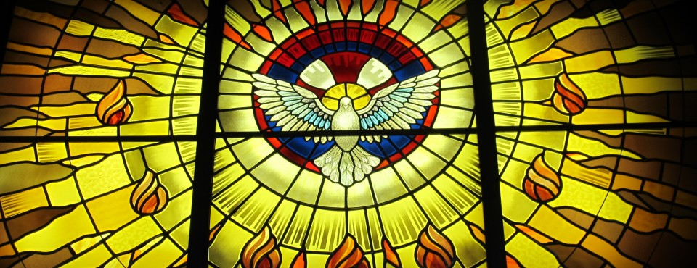

EAST JEFFERSON STREET
PARKING RESTRICTIONS AND ROAD CLOSURES
SPRING 2017

CONSTRUCTION AT JEFFERSON MADISON REGIONAL LIBRARY (JMRL)
MARCH 13 TO MAY 8
FOUR (4) PARKING SPACES, NW CORNER EAST JEFFERSON AND 3RD STREETS NE
The City of Charlottesville has reserved four parking spaces for parish staff on East Jefferson Street during the JMRL construction project. There will be no unauthorized parking allowed in those four spaces from March 13 to May 8. Other spaces are reserved Monday through Friday 6:30 AM to 8 PM for additional construction vehicles and for Payne Ross staff. Except for the four spaces reserved for parish staff, the others will be available to our parishioners on Saturdays and Sundays.

CHARLOTTESVILLE MARATHON
APRIL 1 (Saturday) 6:30 AM-7:05 AM
EAST JEFFERSON STREET BETWEEN 2ND AND 4TH STREETS NE
Race organizers are expecting 1,500 local, regional, national and international runners at Court Square.
East Jefferson Street will be closed between 6th and 4th Streets NE starting on Friday at 10 AM, and will be closed between 4th and 2nd Streets NE for a short time on Saturday morning (6:30 AM to 7:05 AM) for the race start. East Jefferson will re-open at 7:05 AM.

TOM TOM FESTIVAL EVENTS AT LEE PARK
APRIL 14 TO APRIL 16 (Holy Week and Easter)
EAST JEFFERSON STREET BETWEEN 1ST AND 3RD STREETS NE
The Tom Tom Founders Festival will take place in Lee Park on Good Friday, Holy Saturday and Easter Sunday resulting in road closures. On Friday and Saturday, parishioners will be able to access the church by following a detour from 2nd Street NE to East Jefferson Street. On Easter Sunday, East Jefferson Street will be open until 3 PM.

PLEASE NOTE: “DISABLED” PARKING SPACES WILL BE AVAILABLE AT ALL TIMES

